UNIT 4.2

THE COMPUTER SYSTEMS AND SOFTWARE
TUTOR NAME: MS. FATHIMA

SUBMITTED BY FATIMA EJAZ BARRI
TABLE OF CONTENTS
TASK 1.1 Describe components of different computer systems
TASK 1.3 Assess the function of components within a chosen computer system
TASK 2.2 Critically assess the use of different software applications to meet specific purposes
TASK 2.3 Assess the use of web applications to enhance user experience

Task 1:
  - Describe the components of different computer systems
Computer components: definition
All the different pieces of electrical hardware that combined to make up the entire computer system. Components from the whole structure.
- Input devices (keyboard, mouse etc.)
- Output devices (monitor, speakers etc.)
- Secondary storage devices (hard disk drive, cd/DVD/drive etc.)
- Processor and primary storage devices (CPU,RAM)

Input devices: Data and instructions must be inserted into the computer system before any computation on the data presented can be performed. The input device that connects the external environment to the computer system performs this task. Input units enter data and instructions in forms that depend on the device used. For example, data is entered from a keyboard in a manner similar to typing, and this varies from the way in which data is entered through a mouse, which is another type of system input. However all input devices must provide a computer with data that is transformed into the binary codes that the computer’s primary memory is programmed to accept regardless of the form in which they receive their inputs. Devices called input interfaces accomplish the transformation. Input interfaces are designed to match computer system requirements with the unique physical or electrical characteristics of input devices.

In short, an input device performs the following functions.
- It accepts (or reads) the list of outside world instructions and data.
- It converts these instructions and data to an acceptable format for the machine.
- It provides the converted instructions and data for further processing to the computer system.
Output devices: workout devices are the reverse of the input device. It provided the outside world of information and computation results. It connects the computer with the external environment as computers work with binary code; the results are also in the binary. Therefore, it must be converted to an acceptable (readable) human form before suppling the results to the outside world. Devices called output interfaces perform this task.

In short, an output device carries the following functions.
- It accepts the computer-generated results, which are coded and cannot be easily understood by us.
- It converts these coded results in to an acceptable (readable) form for humans.
- It supplied the external world with the converted results.

Secondary storage devices: data and instructions entered by input units in the computer system should be stored inside the computer before beginning the actual processing. Similarly, the results produced by the computer after processing must also be stored in the computer system before being transmitted to the output units. In addition, computer-generated intermediate results also need to be preserved for ongoing processing. A computer systems storage device or primary storage is designed to do all these things. It provides space for data and instructions to be stored, space for intermediate effects and space for results.
In short, the storage unit’s specific functions are to be stored:
- All the data to be processed and instructions (received from input devices) required for processing.
- Processing intermediate results.
- Processing results before releasing these results to an output device.
Processor and primary storage devices:
The system unit is the core of a computer system and the centre focus of processing. Usually there are many electronic components in a rectangular box that process information. The central processing unit (CPU) is also called the processor, the most important part of these components. The CPU is your computer’s brain, which is the key component in the interpretation of the interpretation of the instructions and processing of the computer program. RAM, also referred to as “primary storage” or main memory”, is the next most critical element of a processing. Random access memory (RAM) temporarily stores information used by the CPU while the computer is on and when the computer is turned off, it is erased. A primary storage device is a medium that retains short-term memory while running a computer. Although it has a much lower access time and faster performance, it is also more costly than secondary storage about two orders of magnitude. Examples of a primary storage device are ram (random access memory) and cache. The key difference between the Primary storage and the others is that it is directly accessible by the CPU, it is volatile and it is non-removable.
In short, processor and primary storage devices functions are:
- The processor processes information and data and interprets it to help in performing different functions.
- For a short period, The primary storage device will store information and data.
Example of Input devices
- Keyboard
- Mouse
- Touchpad
- Scanner
- Digital Camera
- Microphone
- Joystick
- Graphic Tablet
- Touch Screen
- Webcam
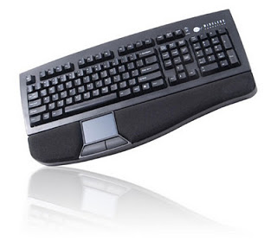
Keyboard: the most common input device is a keyboard. The standard keyboard usually has 104 keys. It is the primary device. It input that uses a cursor to keep your spot on the screen and let you know where to start typing.

Mouse: a mouse is an electro-mechanical device. It used as a pointer. It can perform functions like moving icons selecting menu commands, resizing windows, starting programs and selecting options. Functional device to move the cursor around the screen of the computer. A mouse is a device, which points. As the user rolls it on a flat surface, it usually contains one, two or three keys; the mouse controls the movement of a cursor on the screen. The mouse either marks a place on the screen or makes selections from the data on the screen when the user presses one of the buttons. It can be used for a wide variety in applications from games to graphic design products. It can be used as an alternative to a keyboard, or it can be used to improve input operations in combination with a keyboard.
TYPES OF MOUSE
Traditional mouse
When using a basic construction, traditional computer mouse button will be the most affordable. You connect to your personal machine using mouse port, and some mouse for apple computers uses a USB connection. For those who love the USB port within the mouse port, most mouse involves a USB connection. No special application is needed while rebooting after connecting if you use an older windows version. Every sort of mouse needs to be disassembled periodically for cleaning. For cleaning you should use a lint-free, static-free cloth it will eliminate harm to your mouse to prevent any molested buildup with lint.
Optical mouse
The commonplace has become the optical mouse. They are exercising efficiently lacking the ball found in traditional mouse. Most of them re built to be ergonomic, so you can make very easy use of them. These mouse are less vulnerable to dust collection and require less cleaning than traditional mouse. Most of the optical mouse hooks through the USB port to your device. If you do not need advanced functions enable for the mouse, special software is usually not needed. When using the driver CD that had the mouse, you can enable any special functions that you want your mouse to perform.
Wireless mouse
Wireless mouse provide s cable-free access. That is very useful for both gamers and those who want their mouse to move freely. Some newer laptops are built-in infrared ports where without special hardware you can start that use the mouse. These kinds of mouse include the driver software that is needed during the first minutes; you will normally be able to start using your brand-new mouse. Wireless mouse are optical for easier movement in mind. Many wireless mouse, plus a wireless keyboard, are purchased. You can sit back safely through the computer when you have a large enough monitor and still have the ability to implement it efficiently.
Laptop mouse
Laptop mouse has many identical features as mouse of a desktop. We give a more compact design suitable to smaller spaces in which laptops are used. This mouse are ideal for unusually tracking pads for laptop users. They are useful if your track pad fails and you have zero chance to instantly fix it. Use a retractable cord with a USB connection or wireless connection for laptop mouse.

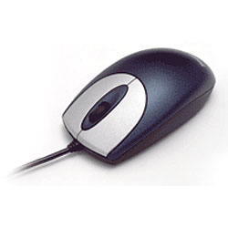

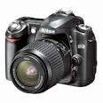
Digital camera: it connects and transmits the images it captures. It can be photos or video. the photos are on the computer later; they can be edited or printed.

Scanner: Scanner is an input device, which works more like a printer for photocopying. It is used when some information is available on paper and for further manipulation; it is to be transferred to the computer’s hard disk.
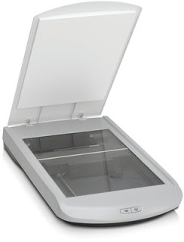

Microphone: this input device is capable of converting acoustic energy into electrical energy. It allows audio signals to be recorded stored, transmitted and processed electronically. Thus, the microphone allows users through their computer equipment to participate in voice conversations.

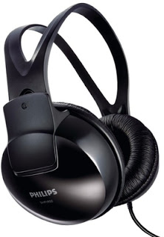

Joystick: a pointing device that is very frequently used in computer games, although handling devices are also common in industrial applications.
Graphic Tablet:

1.2 analyse networking infrastructures

